**Florida State University**



**College of Arts and Sciences**

**A User Accounts Management Module for a**

**Holidays and Events Website**

by **Tao Wang**

April 2018

A project submitted to the

**Department of Computer Science**

In partial fulfillment of the requirements for the

**Degree of Master of Science**

Major Professor: Dr. **Daniel G. Schwartz**

Committee: Dr. **Zhenghao Zhang**, Dr. **Zhenhai Duan**

Table of Contents

1 Acknowledgement 3

2 Abstract 4

3 Introduction 5

4 System Design 7

4.1 MVC Architecture 7

4.2 PYTHON DJANGO Approach 8

4.2.1 Controller 8

4.2.2 Model 9

4.2.3 View 10

4.3 JSP/Servlet/JPA Approach 12

4.3.1 Controller 13

4.3.2 Model 14

4.3.3 View 15

4.4 About Node.js/Express 17

4.4.1 Controller 17

4.4.2 Model 17

4.4.3 View 18

5 Implementation Details 19

6 Future possible extensions 28

6.1 Authorization and authentication 28

6.2 History actions 28

7 Conclusion 29

8 References 30

# Acknowledgement

I would like to thank my major professor Dr. Daniel G. Schwartz for playing a very important role in this project, without his support and guidance this project would have not been possible. My special thanks are to Dr. Zhenghao Zhang and Dr. Zhenhai Duan for expressing their willingness to be on my Master‟s project committee. Lastly, I would like to thank my family, friends, teachers and FSU Computer Science Department staff for their help and support during my Master's program.

# Abstract

“Holidays and Events” is a website where users can buy information about holidays and event in many countries around the world. The price charged is based on the type of locale for which holidays are requested, i.e., city, state, or country. The main parts of the website have already been developed by other students through previous projects. This includes a shopping cart where each user creates accounts for making and recording purchases.

The purpose of this project is to create an administrator’s module for managing user accounts. This includes an interface for viewing each user’s account information and their history of purchases, as well as means for making any necessary updates or modifications.

Today there are many mature web development technologies. In this project, we created the website’s user management module through two approaches: Python/Django and JSP/Servlet/JPA. We also dabbled in the Node.js/Express framework, and tried to the find the differences among their realization of the MVC (model, view, controller) architecture.

# Introduction

We need to develop a user management module to manage an existing website called “Holiday and Events”. The existing website can be shown as below:



In the existing system, the user can enter the information about the country, state, city where he wants to check the holiday information. He then selects the dates to proceed with the holiday information. The sample screens (on computer and on smartphone) are shown as below respectively:



According to the documents of the existing system, there are three main tables on which we would perform create, update and delete operations, and these three main tables would be the targets to be managed in our admin app. These three tables are:

1. Item: consist of selection of option for country, state, city, and year information for which the holiday can be retrieved.
2. Checkout order: user is allowed to make any number of purchases on items and are grouped into one order, and user then pays the price.
3. User account: maintains the contact information and credentials.

Beside the above three tables, there is another table “role”, which describes the role of user (for example, new user or privileged user), we also made the table under our management.

Adding the Admin app, the system would seem like:



The tables to be managed and their relations are shown as following:



# System Design

## MVC Architecture

MVC stands for model-view-controller, and it’s an architecture that aims to separate out the data (model), the display (view), and the application logic (controller). This separation aims to remove any tight coupling between the components, theoretically making code more maintainable and reusable. The request-response flow of MVC architecture could be shown as below: (Figure source: page 65 of “Getting MEAN”, by Simon Holmes)



In a web app, what we do will be designed to take an incoming request, do something with it, and return a response. More specifically, under the MVC architecture, the behavior is:

1. A request comes into the application.
2. The request gets routed to a controller.
3. The controller, if necessary, makes a request to the model.
4. The model responds to the controller.
5. The controller sends a response to a view.
6. The view sends a response to the original requester.

Different web development frameworks have different realization of MVC architecture, now let us study them (Python/Django, JSP/Servlet/JPA and Node.js/Express) one by one. Our project was implemented on two of these frameworks: Python/Django and JSP/Servlet/JPA.

## PYTHON DJANGO Approach

Before we started to design the project, there would be one thing we want to know: what would a professional web admin app looks like? And this question was the exact reason why we chose the Python/Django as our first framework upon which to accomplish our project.

We know that one of Django’s advantages is its built-in admin interface. So what we need to do was inspecting the exist MySQL database and get the data, converting the data into Django format, and then create an admin interface. The automatically created admin interface is very powerful, and you could do some customization on it.

Django follows the MVC pattern closely, however it does use its own logic in the implementation. Because the “C” is handled by the framework itself and most of the excitement in Django happens in models, templates and views, Django is often referred to as an MTV framework. In the MTV development pattern: ( <https://djangobook.com/model-view-controller-design-pattern/> )

* M stands for “Model,” the data access layer. This layer contains anything and everything about the data: how to access it, how to validate it, which behaviors it has, and the relationships between the data.
* T stands for “Template,” the presentation layer. This layer contains presentation-related decisions: how something should be displayed on a Web page or other type of document.
* V stands for “View,” the business logic layer. This layer contains the logic that accesses the model and defers to the appropriate template(s). You can think of it as the bridge between models and templates.

### Controller

The router function lies in the url.py files of Django’s various hierarchical directories, and following the contents of these url.py files, you will eventually get to the controller file, which is named “view.py”.

The following figure is an example of an urls.py file:

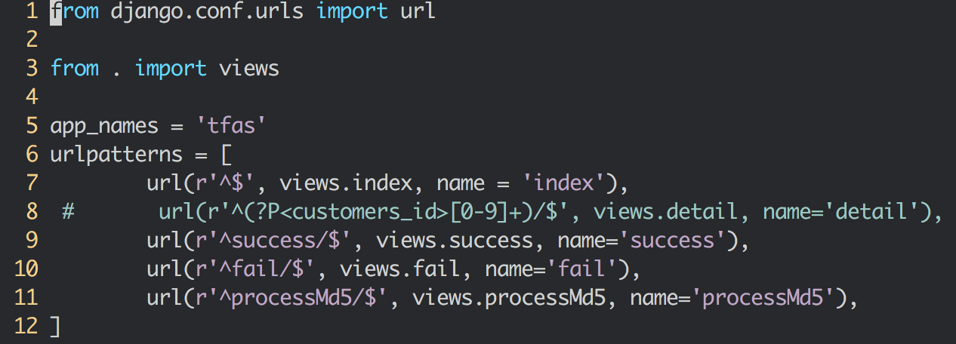

This is probably the only unfortunate bit of naming in Django, because Django’s view is the controller in MVC, and MVC’s view is actually a Template in Django. It is a little confusing at first, but as a programmer getting a job done, you really won’t care for long.

The figure below is an example of a views.py file:

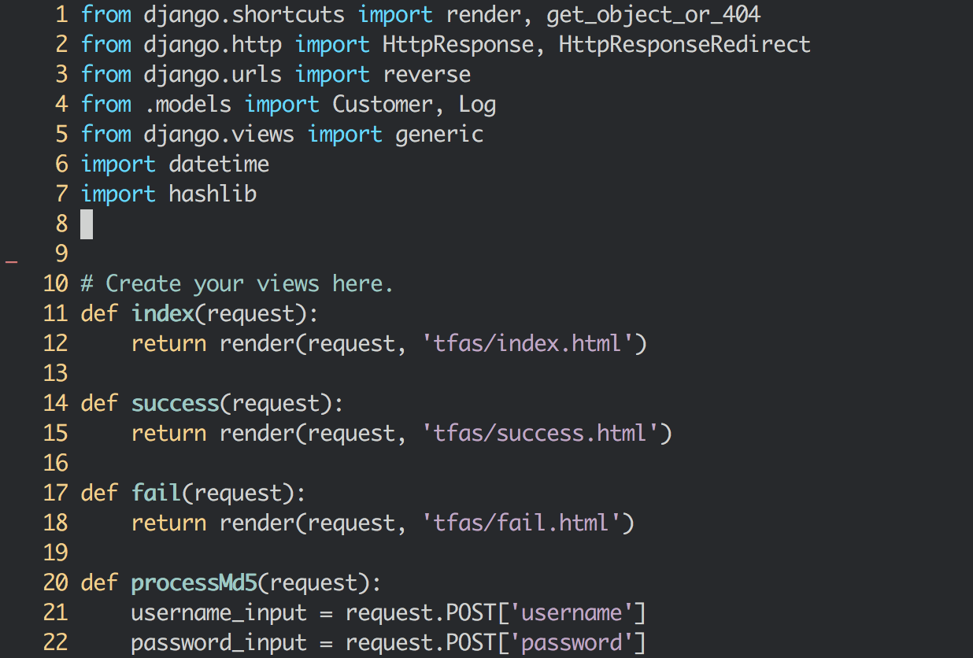

### Model

Besides the existing tables, Django added several other tables to realize the authentication and authorization, the added tables are shown as below:



Through Django’s “inspectdb” module, we could get the data out from MySQL database, and new file named “model.py” will be created.

The figure below shows what looks like in a model.py file:



These classes defined in the models.py file could be directly used the manipulated data in database, and hide the low-level details for programmers.

### View

All the things displayed on a Web page lie in various html pages, which are under the “template” sub-folder in many places of Django’s hierarchical directory structures.

Django adopts a template inheritance method to reuse the html files you defined previously. In node.js, there is a similar style’s realization; but in JSP/Servlet, it will be very difficult to realize template inheritance without third-party’s solution (tiles, for example).

To elucidate the template inheritance, let us take a look at the base_site.html:

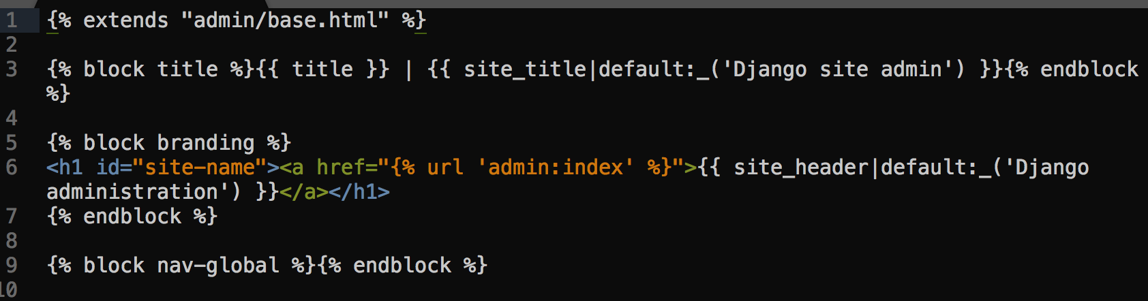

The base_site.html uses admin/base.html as a template, and filled something in blocks: block title and block branding. There are a lot of other blocks defined in “base.html”, but those blocks will not be changed.

If we want to develop a web page based on this base_site.html, for example, the index.html:

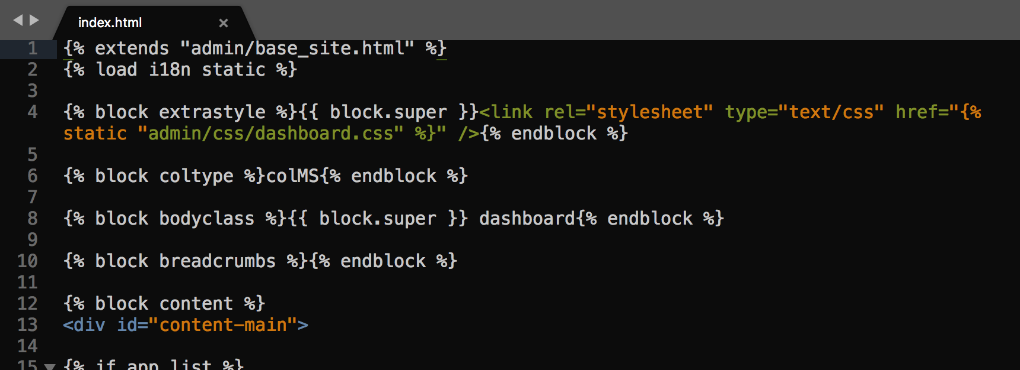

The index.html uses base_site.html as its template, this time block extrastyle and block content will be changed.

## JSP/Servlet/JPA Approach

Java Servlets are programs that run on a Web or Application server and act as a middle layer between a request coming from a Web browser or other HTTP client and databases or applications on the HTTP server. Servlets correspond the “Controller” part of MVC.

JSP pages are text documents that contain two types of text: static data, which can be expressed in any text-based format (such as HTML, SVG, WML, and XML), and JSP elements, which construct dynamic content. JSP pages correspond to the “view” part of MVC.

Mapping Java objects to database tables and vice versa is called Object-relational mapping (ORM). The Java Persistence API (JPA) is one possible approach to ORM. Via JPA the developer can map, store, update and retrieve data from relational databases to Java objects and vice versa. JPA corresponds to the “model” part of MVC.

Their relation could be shown as below”



Their corresponding files in Eclipse:



### Controller

Entrance of the app was set in the web.xml file, under the welcome-file-list, we set the first place to go is the “login” servlet:



Then, at the beginning of the LoginServlet.java, we use an annotation to show this would be the entrance:



Each servlet file corresponds to a specific url. In each servlet file, there would be some entrances to JSP files, which would eventually render to web user (there could be parameters to be transferred between servlets and JSP pages):



### Model

To realize the authentication of our project, in this approach we added a table named “admin_user”, which is shown as below:



The mapping between Java objects and database tables is defined via persistence metadata. The JPA provider will use the persistence metadata information to perform the correct database operations.

JPA metadata is typically defined via annotations in the Java class. Alternatively, the metadata can be defined via XML or a combination of both. A XML configuration overwrites the annotations.

The following description is based on the usage of annotations.

JPA defines a SQL-like Query language for static and dynamic queries.



### View

JSP pages do not have the concept of template inheritance, which is the basic function of Django and Node.js. If you want some functions alike, third-party’s solution should be used. However, JSP tags, to some extent, could give you some degree of code reuse. For example, we define a group of code to be used at the beginning of a JSP file, and named it as “_head.jsp”:



The we could reuse this code snippet in another JSP file:



## About Node.js/Express

Although time is not enough for us to achieve the third approach, we did make some study at the Node.js/Express framework. The newest engine of Node.js is famous for its processing efficiency and response speed, which make it the best selection for website with very-large-scale users. Besides that, the combination of Node.js, Express, Angular and MongoDB(MEAN) solution forms a framework which covers the front-end and server-side (so called full stack) improves the software engineers’ efficiency. For the developers, only one programming language is needed: JavaScript.

### Controller

The app.js file in the root directory of the project define the route file to be used. The figure below shows the control flow to visit the home page:



### Model

The Node.js/Express framework is suitable for MongoDB (a document database), because the JavaScript object is stored as JSON format, which could be stored directly into MongoDB. The data to be managed in our project was stored in MySQL, which is a relational database, it is very difficult to transfer the existing data into MongoDB.

One way to solve the problem is to make the MySQL API RESTful, and visit the REST API of MySQL to get the JSON format data. We tried this method, the data to be got is show as following:



There are some many-to-many and many-to-one relations in our existing data, which would not be taken account of in JSON, we would have to manage all these relations manually. From this point of view, Django and JPA approaches is better than Node.js to manage relational data.

### View

We use the Node.js’ default template engine “jade(pug)”, jade file doesn’t actually contain HTML tags in the templates, instead, Jade takes a rather minimalist approach, using tag names, indentation, and a CSS-inspired reference method to define the structure of the HTML.

We’ve seen the jade file for home page, here we show it again:



# Implementation Details

In this section, we would describe the detail web pages of our JSP/Servlet/JPA approach.

The MySQL database was assumed to be installed on the local machine, and thus the IP address was “localhost” or “127.0.0.1”. If the MySQL database was not installed locally, the real IP address should be used, and some configuration changes should be made accordingly.

First, the login page:



After user’s login, the home page:



On the header part of every page (except login page), there some navigation shortcuts on the upright corner. Users could get to home page, password changing page or log out from these navigation short cuts.

In the body of the home page, there are two domains: authentication and authorization, and online_shopping. The first domain focused on the admin user’s management, and the second domain focused on the management of the existing holiday application and events table: online_shopping.

In the authentication domain, admin users could be added, updated or deleted. For example, if the “add” icon of “Users” is clicked, the following page will appear:

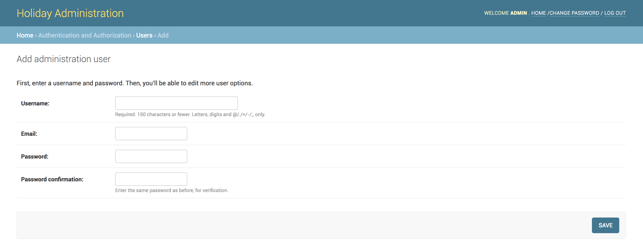

You could add new admin user on this page.

if “Users” is clicked, the following page will appear:

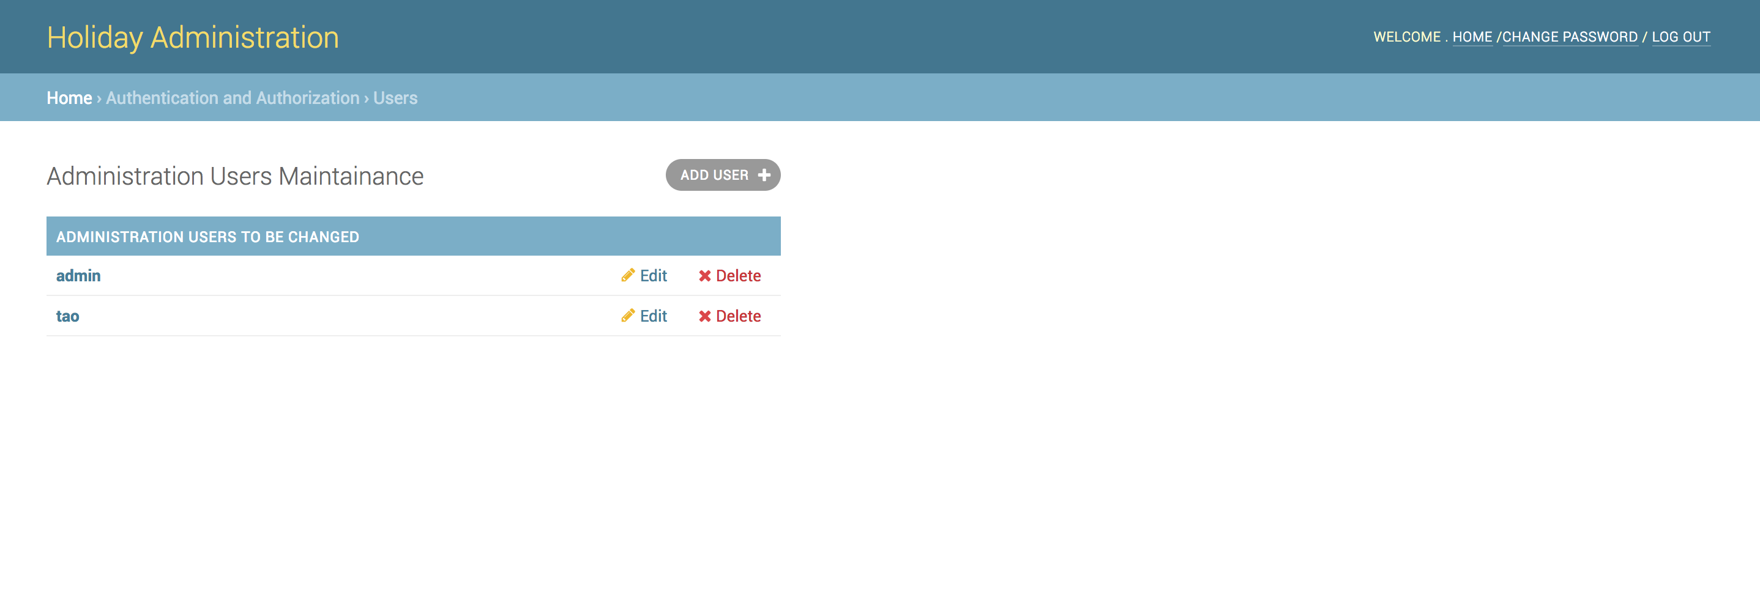

All the current admin users would be listed on this page, if you further click on one of the admin user, for example, click on “admin”, the following page will appear:

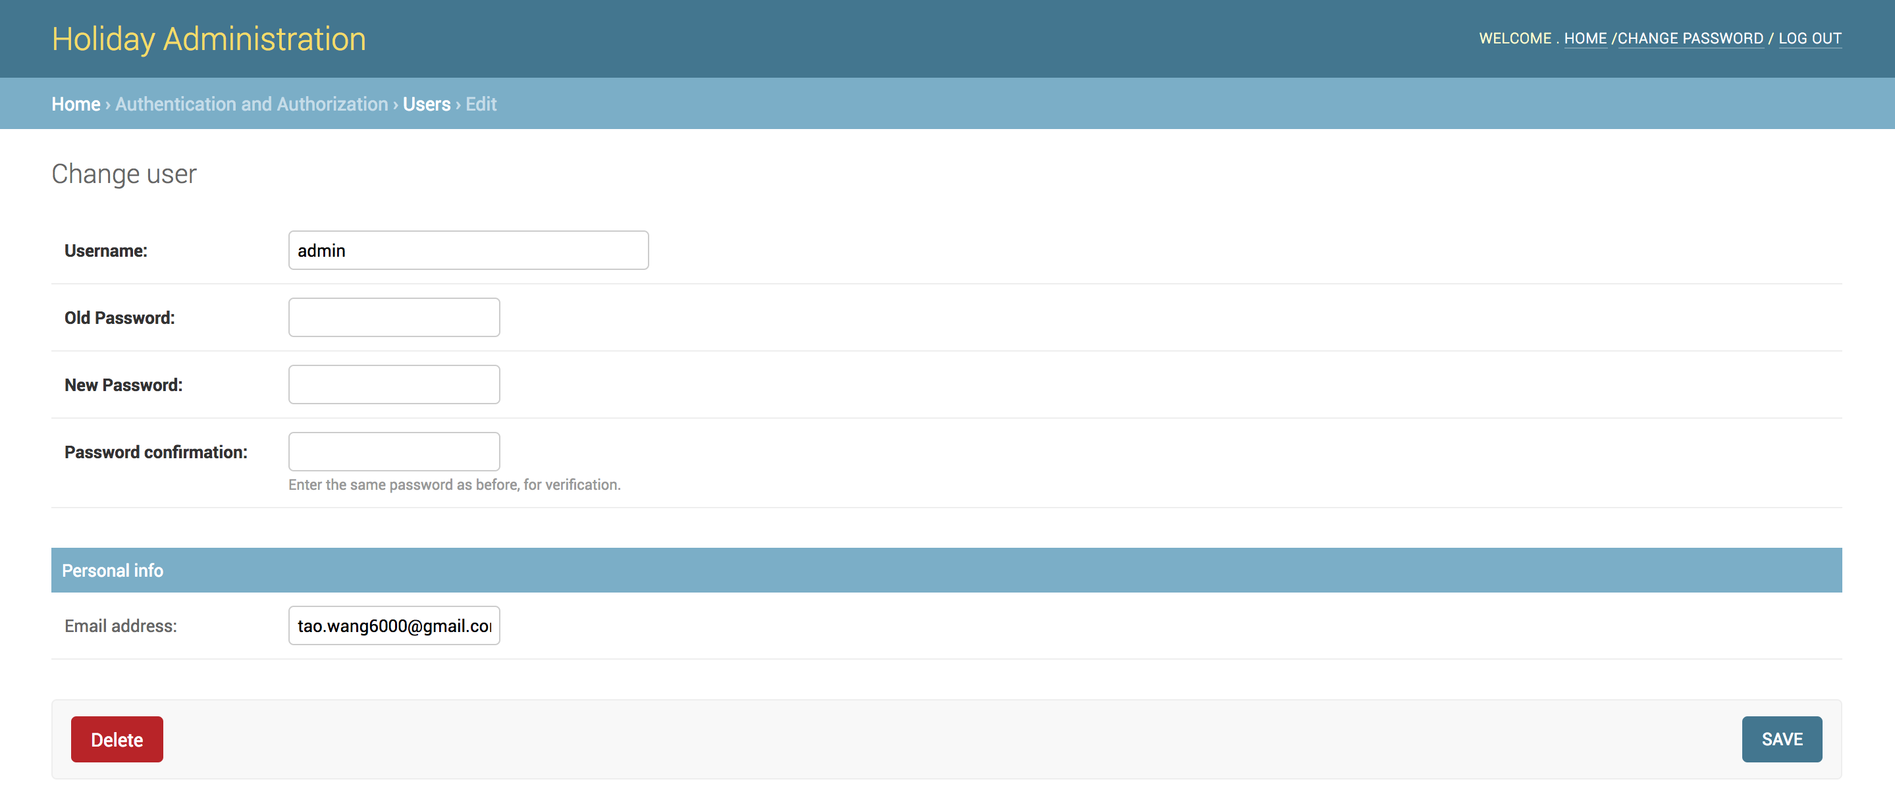

The exist admin user could be edited.

In the “ONLINE_SHOPPING” domain, there four lines, where four tables “User accounts”, “Checkout Orders”, “Items”, and “Roles” are listed. If you click the “add” icon of the four tables one by one, the following pages will appear respectively:

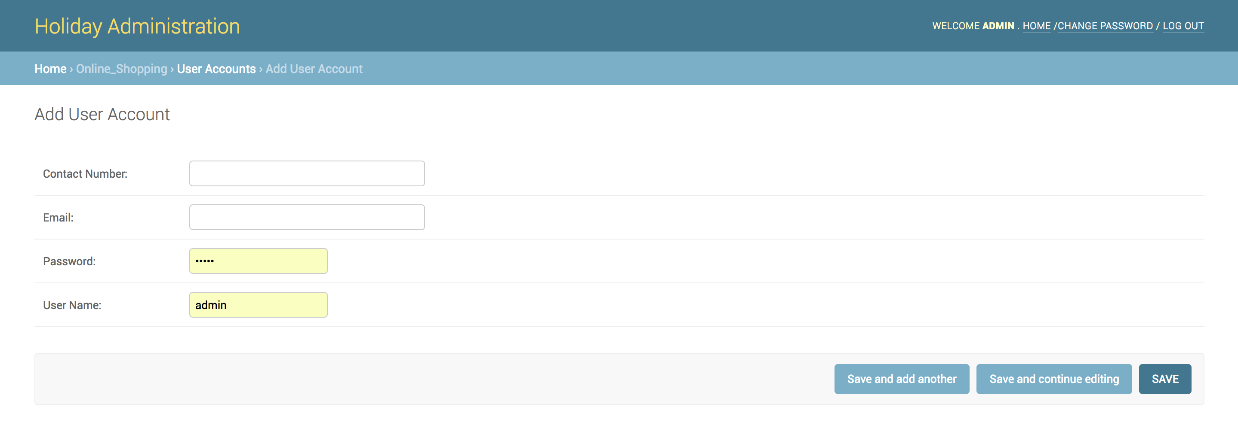

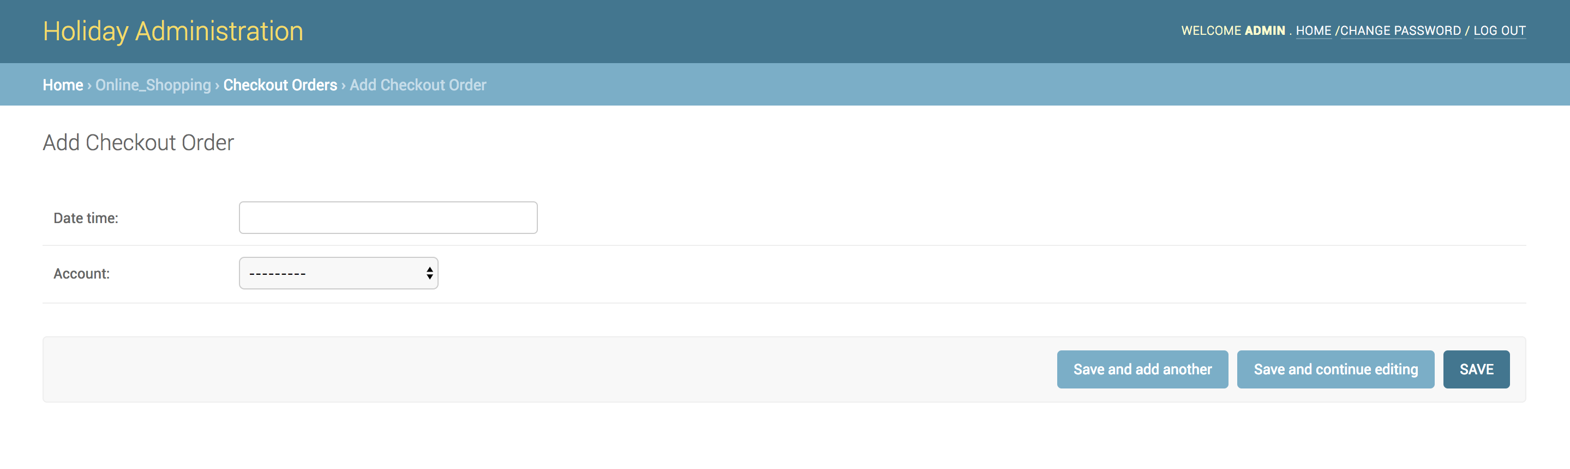

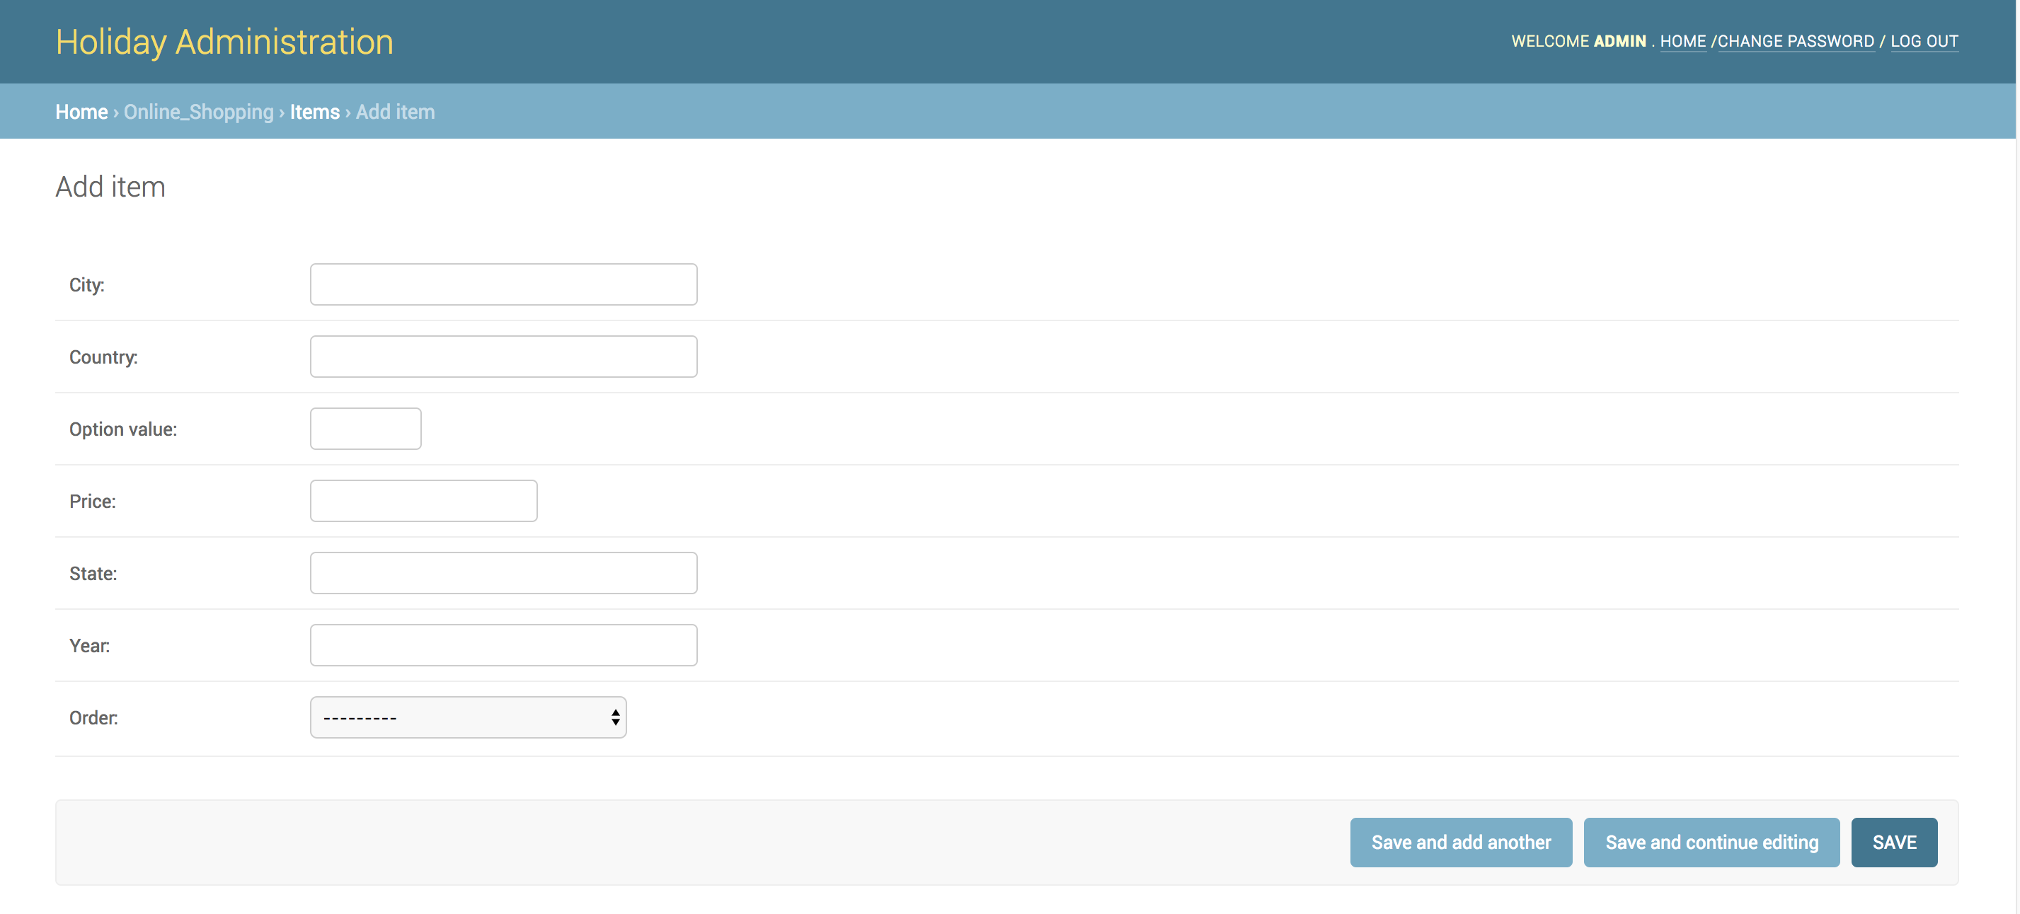

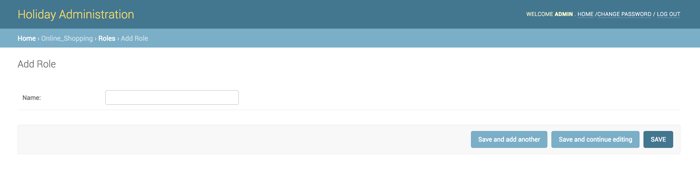

Through this way, corresponding tables members could be added.

If you click on the tables’ names one by one, the following pages will appear:

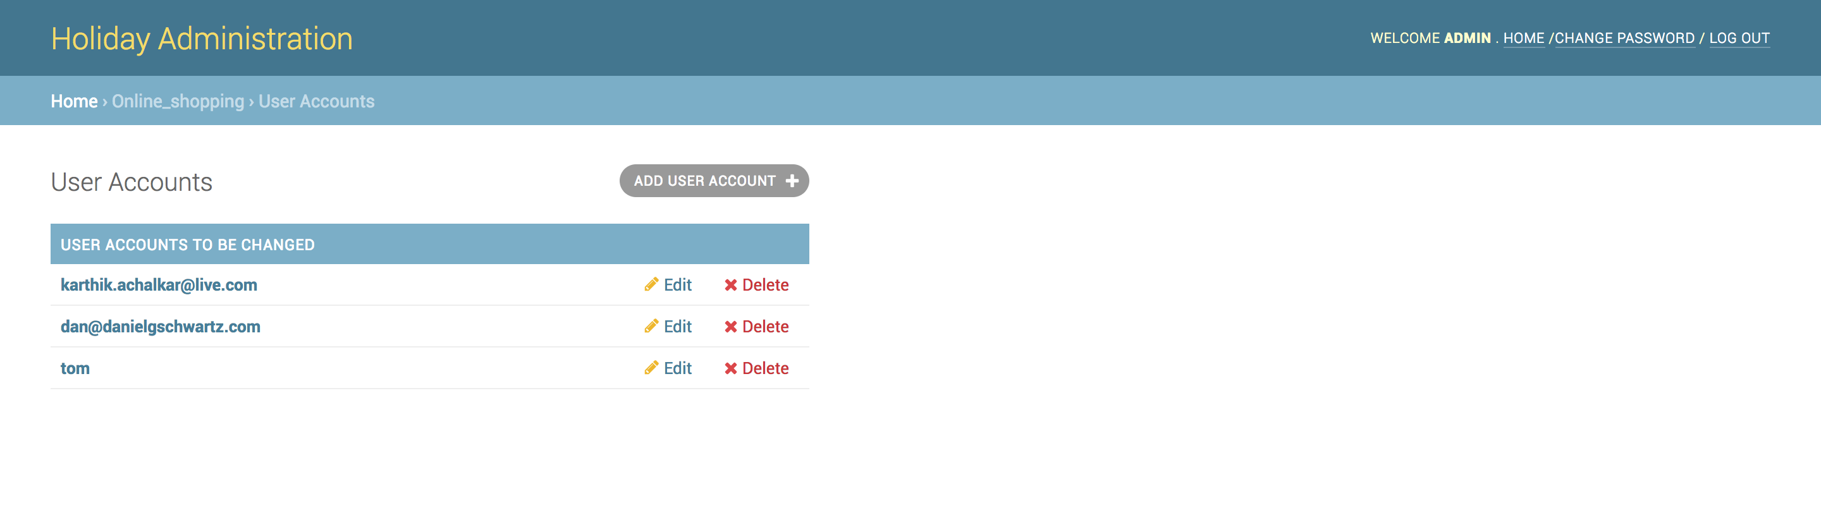

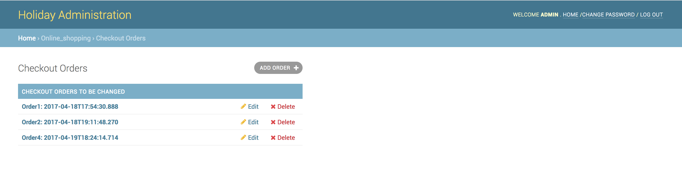



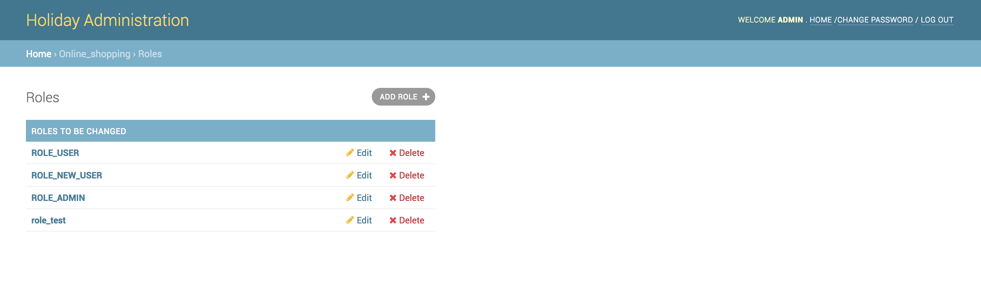

If you further click on the various table’s element’s name, the following pages will appear:

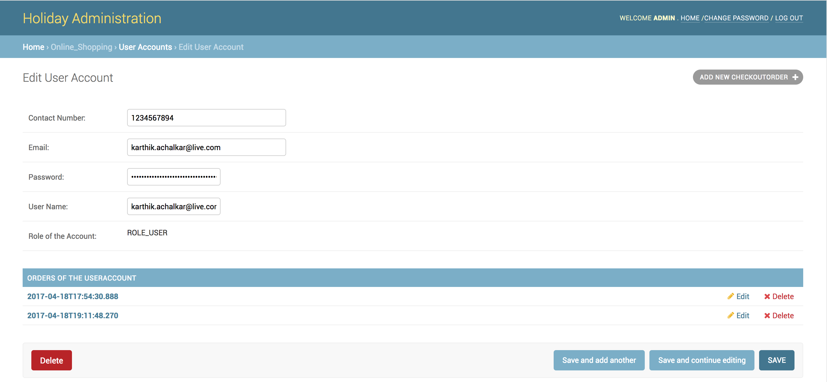

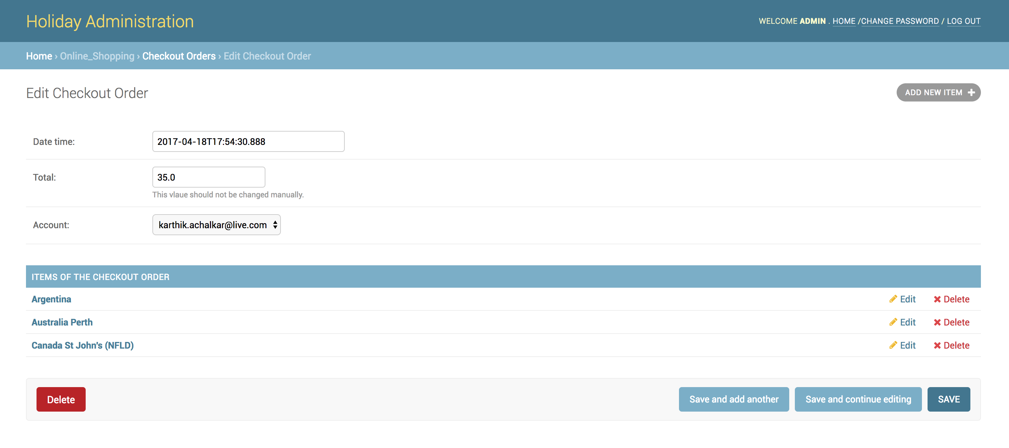

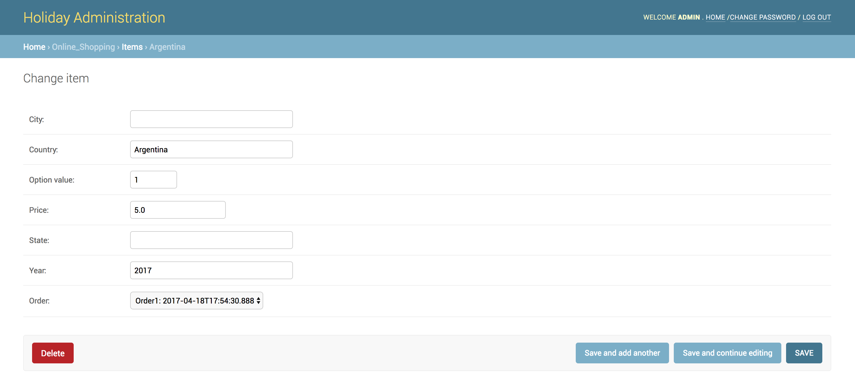

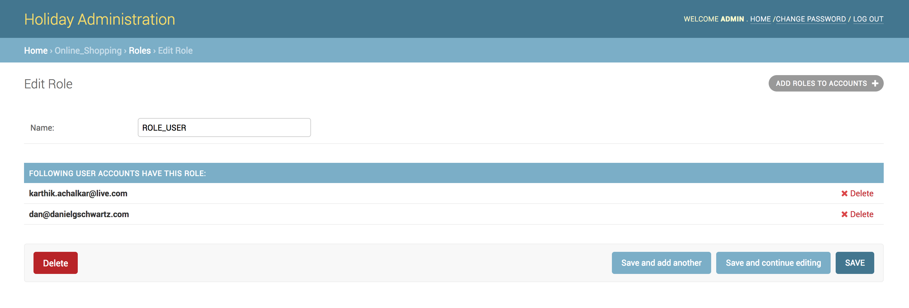

At each page above, the correspond element could be added, edited or deleted.

For example, add a new User Account:

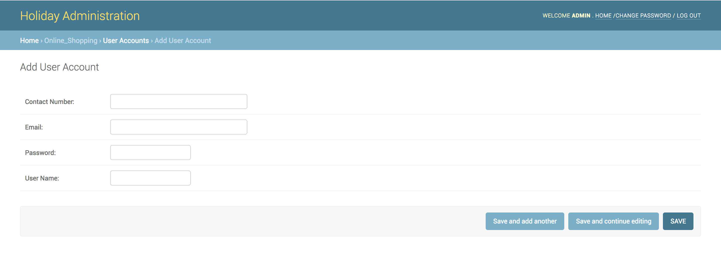

Edit a User Account:

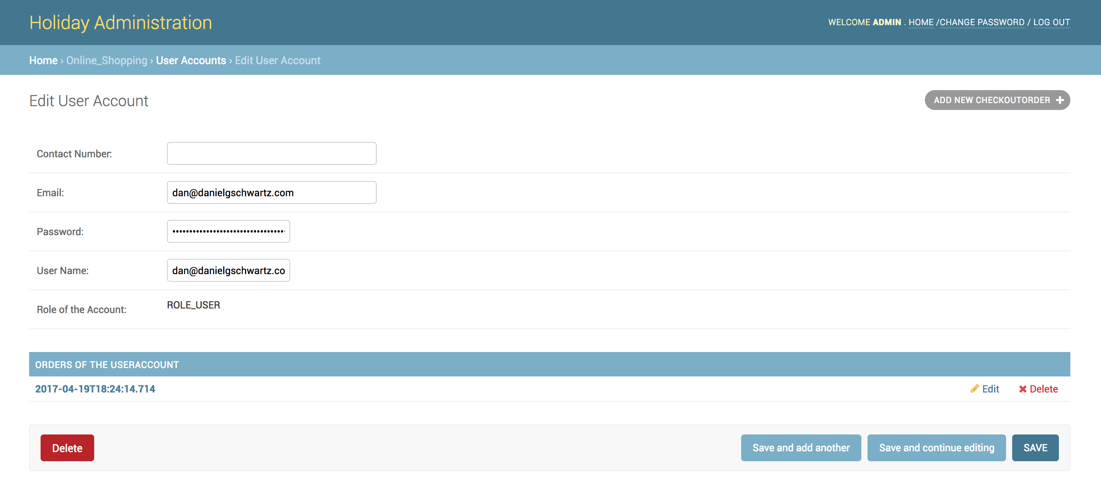

Add a new checkout order:

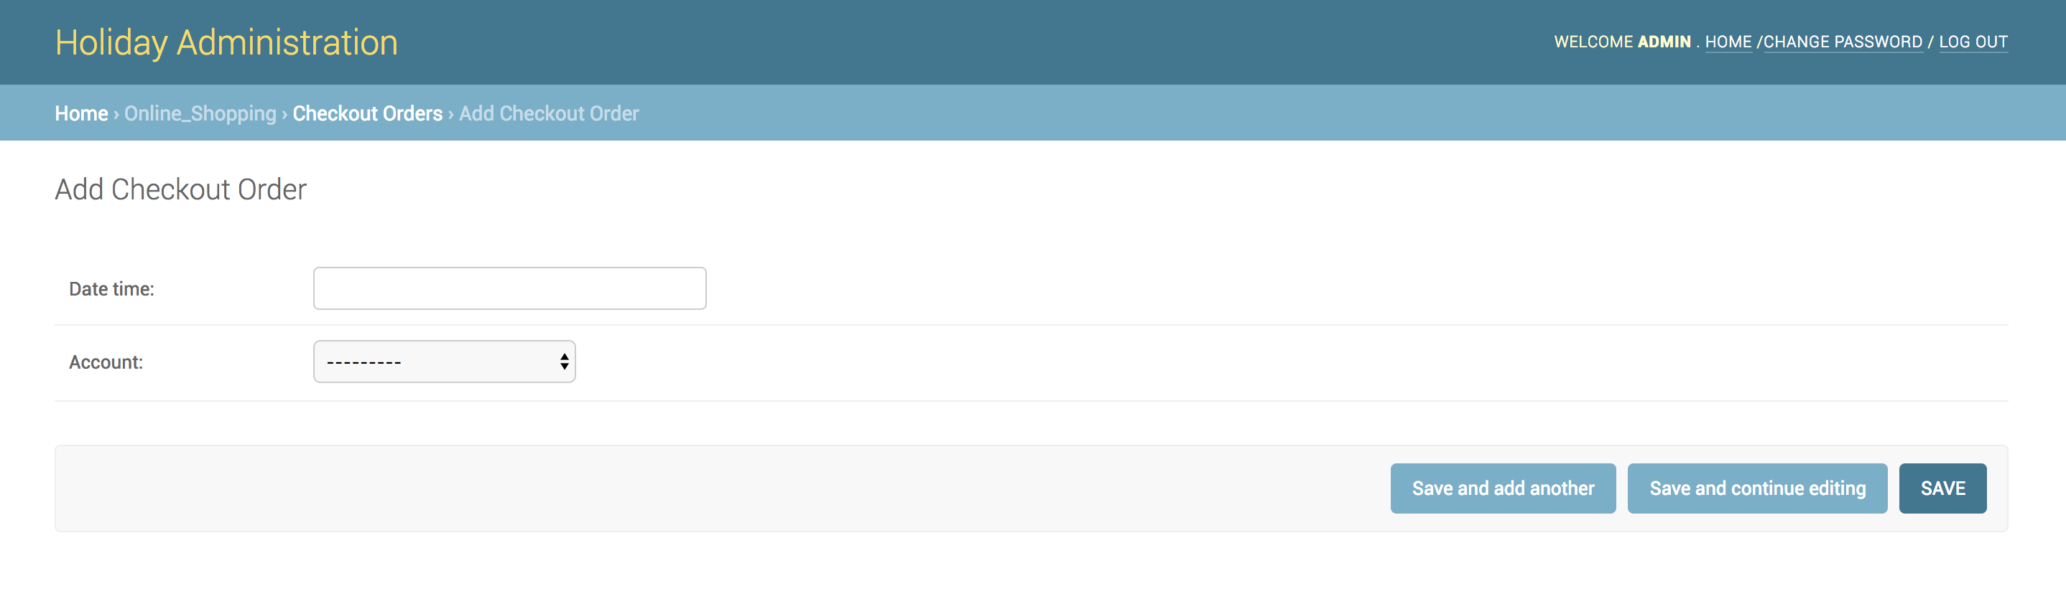

Edit a checkout order:

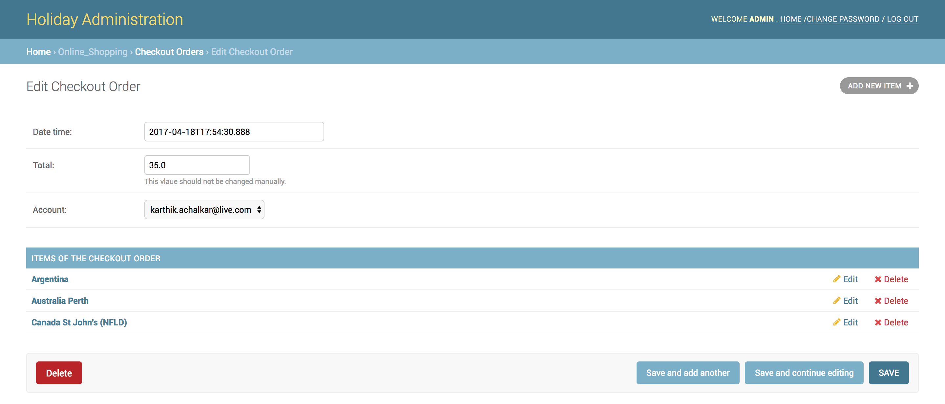

Add a new item:

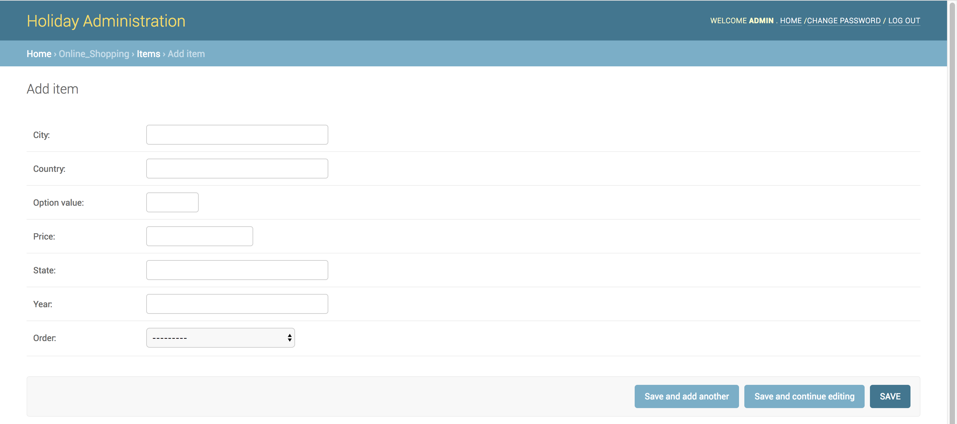

Edit an existing Item:

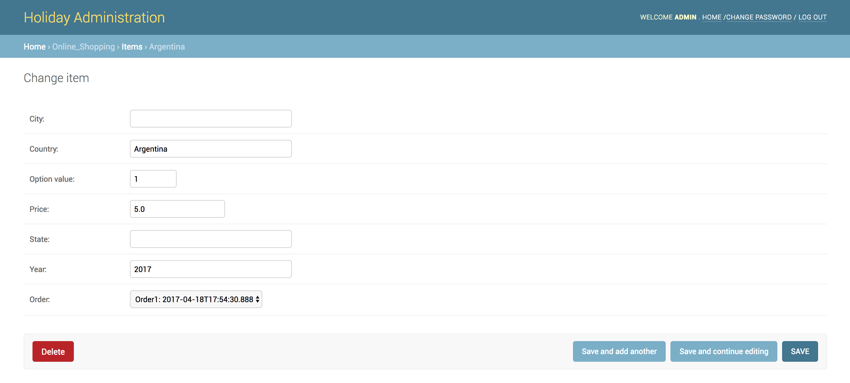

Add a new role:

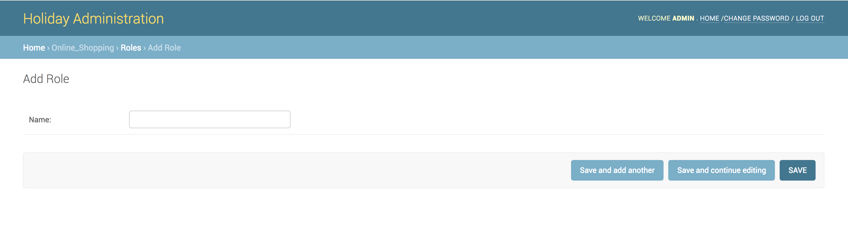

Edit an existing Role:

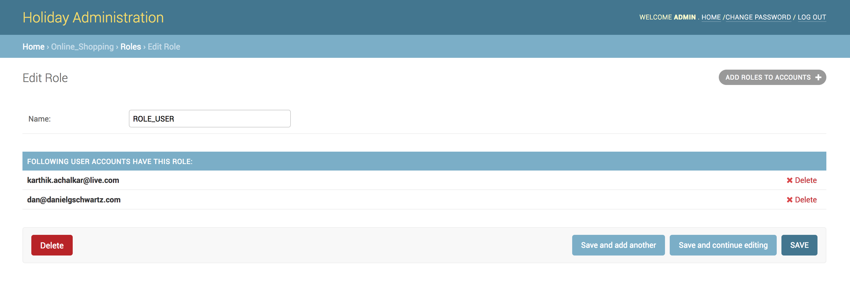

One thing to mentioned is, at this stage, the former project’s password encrypting code has not been integrated in this code. So be cautious if you want to create or edit User Account (where password updating may occur) using this admin interface, because the password will be saved as plain text instead of an encrypted one. You could achieve your goal by using the previous project’s password reset function to change the account’s password afterwards.

# Future possible extensions

There are several areas where the application (Java approach) can be enhanced to give an advanced experience. They are listed below:

## Authorization and authentication

Admin users could be further classified into different groups, each group could have different privileges.

Currently there is no user groups, and there is no classification of various privileges among users.

## History actions

An option of logging admin users’ actions could be further provided. These logs would give a very useful information about different admin users’ behavior trajectories.

# Conclusion

The application has implemented the website management module. This project has helped me in understanding the challenges involved in developing a MVC based application with different approach. The time spent in this project has been a very valuable experience to me. At the time of this project’s starting in last semester, I was totally a novice in web development, but now I am a professional in JSP/Servlet web development, and I also have the skill to develop under Python/Django or Node.js/Express environment. All the credit should go to Dr. Daniel G. Schwartz for his help. I thank him very much for offering me this project.

# References

<https://docs.djangoproject.com/en/1.11/>

<https://github.com/s-block/django-nested-inline>

<https://o7planning.org/en/10285/create-a-simple-java-web-application-using-servlet-jsp-and-jdbc>

<http://www.objectdb.com/tutorial/jpa/start>

<https://www.w3schools.com/>

<https://github.com/kenodressel/mysql-to-rest>

<https://github.com/mysqljs/mysql#introduction>

Getting MEAN, by Simon Holmes, ISBN: 9781617292033